One DB Context and One DB,

Problem is, when working with default folder structure, PMC know where is the DB Context, Where is Migrations folder and Where is the Configuration files, but now we have changed them, so in this new context, how the PMC will works.

Still we have Single DB and Single PMC in the Project. Nothing changed

Next, One DB, Two DB Context/UOW, is this right ????

Next Mutiple DBs and Multiple DB Context/UOW

There is no One to one relationship between DBContext and DB, Two DB context and can target One DB.

DBContext is UOW, DDD suggest on UOW for one BC, I thinks so.

UOW bind the Collection of Domain Objects are those are needed to be updated together in a BC or Use Case.

We Can have more than one UOW in one BC, I think totally depend upon the Domain Invariants and UC we are implementing.

Is it just the grouping to Domain Objects or it affects are working of the UOW.

If an application has 10 entities, having one UOW/DBContext that wraps all 10 entites and having 2 UOW those wrap 5 entities each are equal. Does this affect the functinlaity of the UOW, Concurrency, Transactions issues.

Migration blank folder already exist in the Solution, now run the command

enable-migrations -ContextTypeName CleanArchTemplate.Common.UOW.ApplicationDbContext -MigrationsDirectory Common\Migrations

After running the Comand Configuration Class is generated.

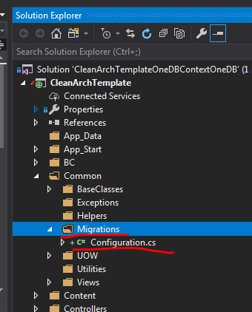

Configuration Class Code

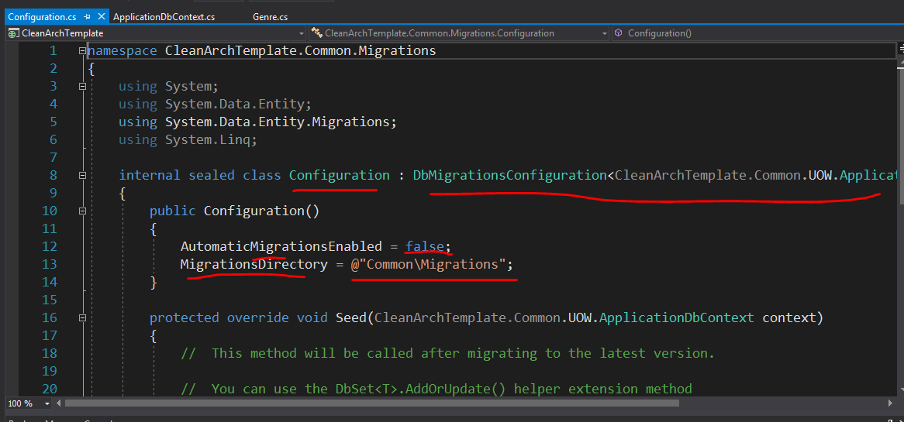

add-migration InitialModel –configuration CleanArchTemplate.Common.Migrations.Configuration

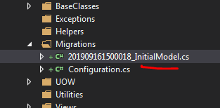

Before updating the Data Base, Change the Database name in the Connection String, and Delete the DB from the App_Data folder. Now Run this Command, New DB will be created if not exist, 5 Tables will be created

update-database –configuration CleanArchTemplate.Common.Migrations.Configuration

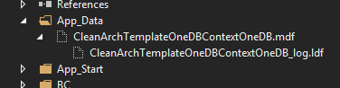

IN the main web.config file

<connectionStrings>

<add name="DefaultConnection" connectionString="Data Source=(LocalDb)\MSSQLLocalDB;AttachDbFilename=|DataDirectory|\CleanArchTemplateOneDBContextOneDB.mdf;Initial Catalog=CleanArchTemplateOneDBContextOneDB;Integrated Security=True"

providerName="System.Data.SqlClient" />

</connectionStrings>

Connect to DB in the App_DB and See the changes

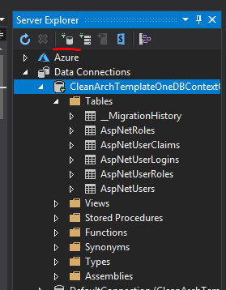

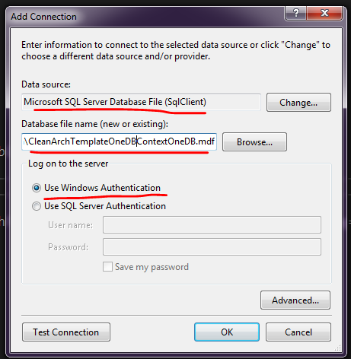

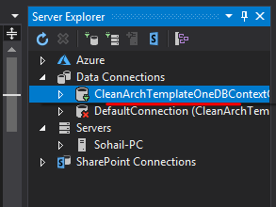

Delete Connection, Detaching DB in the Server Explorer only Delete the Connection to the DB, but do not delete the DB

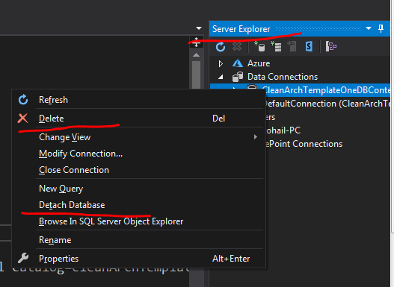

Final shape of DB after first migration

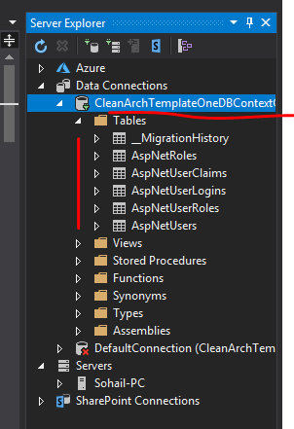

For one DB Context and One DB

enable-migrations -ContextTypeName CleanArchTemplate.Common.UOW.ApplicationDbContext -MigrationsDirectory Common\Migrations

add-migration InitialModel –configuration CleanArchTemplate.Common.Migrations.Configuration

update-database –configuration CleanArchTemplate.Common.Migrations.Configuration

For Two DBContext and One DB

Try to keep Common Migration Folder but did not work. It one migration is pending, apply that migration then generated new migration. But previous migration has been applied. Then I seperted both of the Migrations folders and now it worked.

Enable Migrations for Both of the DB Context having same Conections String

enable-migrations -ContextTypeName CleanArchTemplate.BC.AccessControl.UOW.ApplicationDbContext -MigrationsDirectory BC\AccessControl\UOW\Migrations

ApplicationDbContextConfiguration.cs Class name and File name

enable-migrations -ContextTypeName CleanArchTemplate.BC.Home.Domain.Persistence.UOW.HomeDbContext -MigrationsDirectory BC\Home\Domain\Persistence\UOW\Migrations

HomeDbContextConfiguration.cs Class name and File name

=====================================================================================

Add and update Migration for One DB Context

add-migration ApplicationDbInitialModel –configuration CleanArchTemplate.BC.AccessControl.UOW.Migrations.ApplicationDbContextConfiguration

update-database –configuration CleanArchTemplate.BC.AccessControl.UOW.Migrations.ApplicationDbContextConfiguration

Add and update Migration for 2nd DB Context

add-migration HomeDbContextConfigurationInitialModel –configuration CleanArchTemplate.BC.Home.Domain.Persistence.UOW.Migrations.HomeDbContextConfiguration

update-database –configuration CleanArchTemplate.BC.Home.Domain.Persistence.UOW.Migrations.HomeDbContextConfiguration

